**Hydraluxe Aquastar**

Page 1:

Machine photo

Tagline: ***Glow Starts Here***

**Footer line: *Delivering deep cleansing, exfoliation, hydration, and real-time radiance***

**Page 2:**

***One Machine. Endless Skin Solutions***

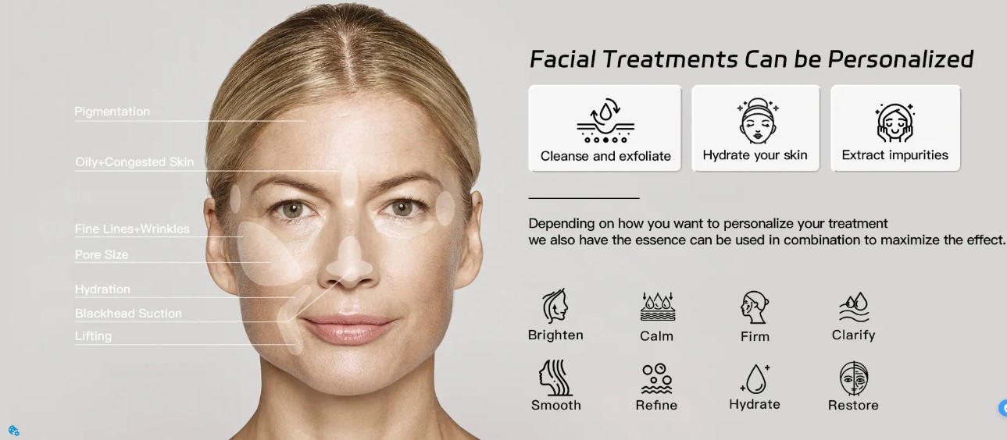

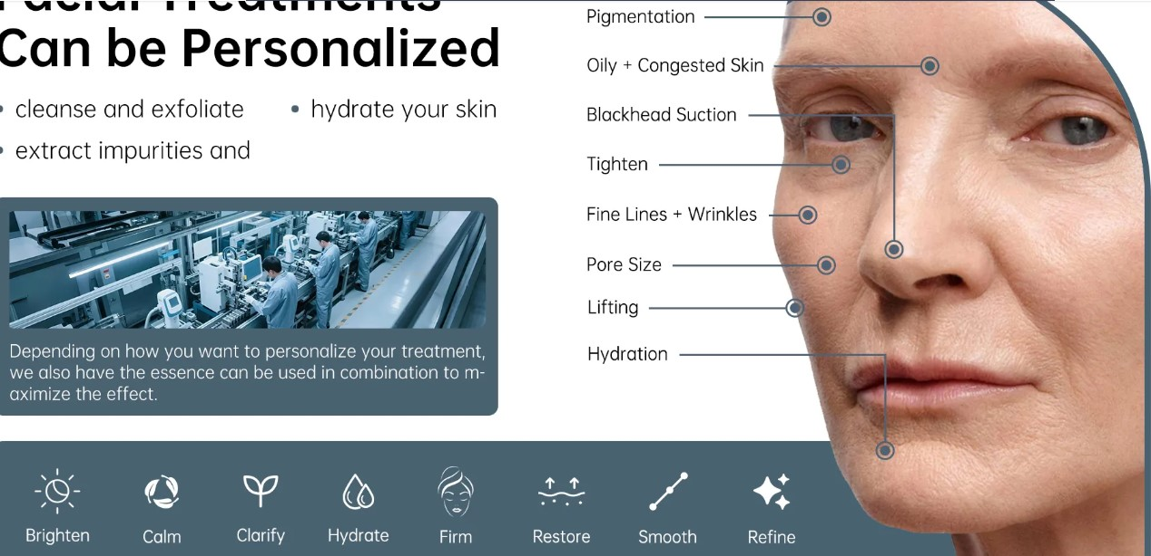

Add photo like mentioned above with photo of face and indication working highlighted on face with machine function with icon.

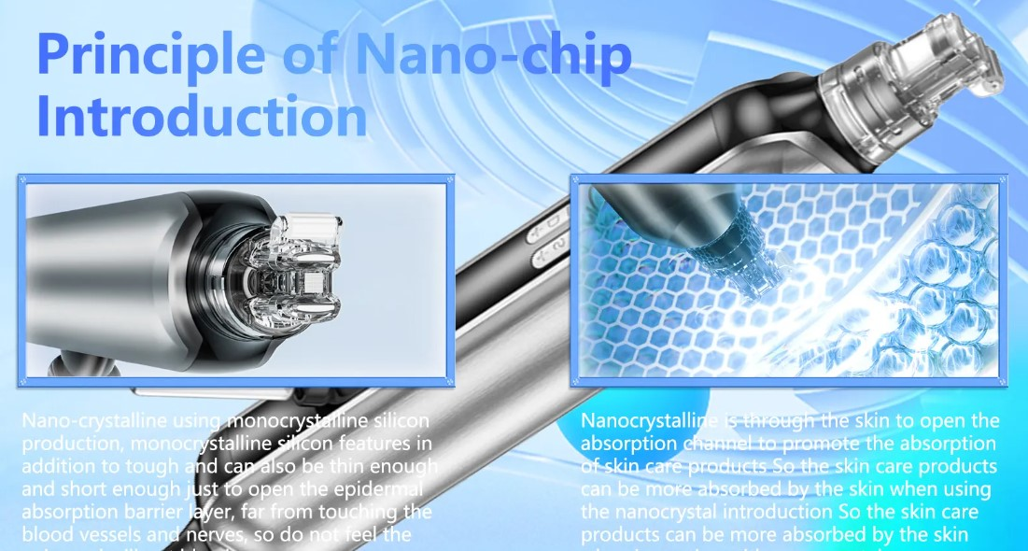

Add nano chip EMS photo

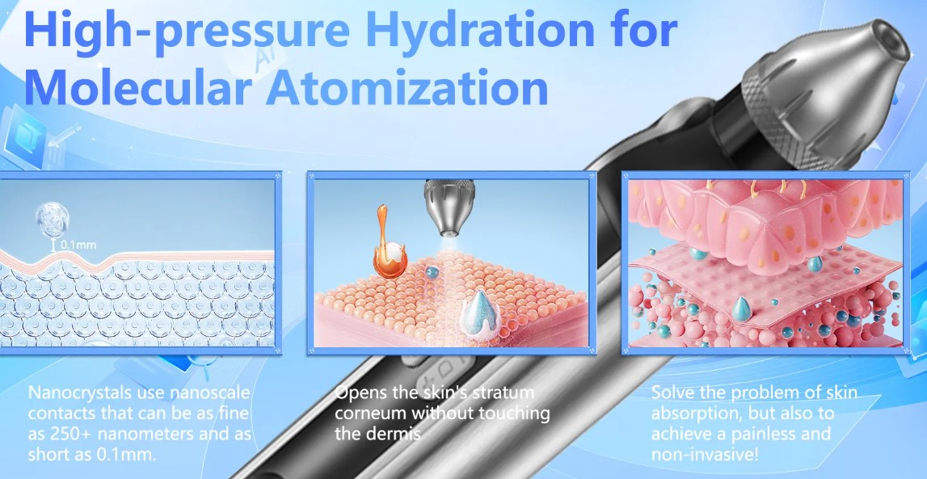

Use the 3 photos from above as featuring high pressure hydration

***Scan. Diagnose. Personalize Every Facial***

Real-time, high-resolution facial scanning

Detects oiliness & Hydration, pigmentation, pores, Inflammation, fine lines levels

Advanced AI-driven skin condition analysis

personalized, data-based HydraFacial treatments

consultation with visible skin metrics

(right side machine display with analysis )

Add specification chart